|  |  |  |  |
| --- | --- | --- | --- |
| B1 | B2 | B3 | Y |
| 0 | 0 | 0 |  |
| 0 | 0 | 1 |  |
| 0 | 1 | 0 |  |
| 0 | 1 | 1 | 1 |
| 1 | 0 | 0 |  |
| 1 | 0 | 1 | 1 |
| 1 | 1 | 0 | 1 |
| 1 | 1 | 1 | 1 |



Y = ( nB1 ^ B2 ^ B3 ) v ( B1 ^ nB2 ^ B3 ) v ( B1 ^ B2 ^ nB3 ) v ( B1 ^ B2 ^ B3 )



Umsortieren und Erweitern Idempotenzgesetz



Y = ( nB1 ^ B2 ^ B3 ) v ( B1 ^ B2 ^ B3 ) v ( B1 ^ nB2 ^ B3 ) v ( B1 ^ B2 ^ B3 ) v ( B1 ^ B2 ^ nB3 ) v ( B1 ^ B2 ^ B3 )



Y = [( nB1 v B1 ) ^ ( B2 ^ B3 )] v [(B1 ^ B3 ) ^ ( nB2 v B2 )] v [( B1 ^ B2 ) ^ ( nB3 v B3 )]



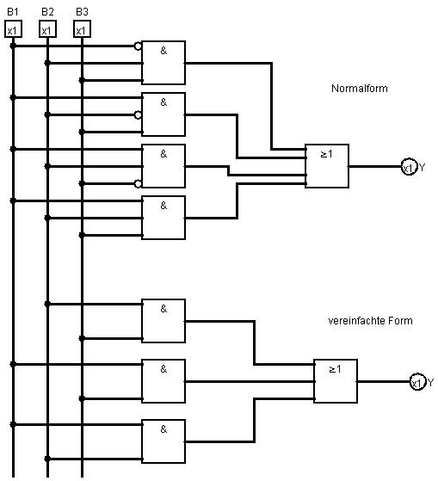Y = ( B2 ^ B3 ) v (B1 ^ B3 ) v ( B1 ^ B2 )